Getting Started with BIG-IP

*Last update: 11 June 2025*

Contents

1 – Intro to BIG-IP System 3

Architecture 3

Internal Structure 3

BIG-IP Device 3

BIG-IP Configuration Tools 3

2 – Setting Up BIG-IP 4

Configure Management Interface 4

Changing Default Administrative Passwords 4

Activating BIG-IP License 4

Provisioning BIG-IP System 4

Installing Device Certificate 4

Platform Configuration 5

Management 5

Time 5

Access 5

Network and High Availability (HA) 5

NTP 5

Device DNS 5

3 – Archiving BIG-IP Configuration 6

# 1 – Intro to BIG-IP System

## Architecture

* Default deny system
* Full proxy architecture
  + allow client-side connection can have different connection behaviour than server-side connection

### Internal Structure

* Two key functions
  + Application delivery services
    - TMOS (Traffic Management OS) 🡪 different independent modules run on top of TMOS
    - Examples: LTM, APM
  + Administrative function
    - Linux OS
    - TMOS Shell or GUI

### BIG-IP Device

* Pin out references
* LCD
  + [Clearing the LCD and Alarm LED remotely](https://my.f5.com/manage/s/article/K11094)

### BIG-IP Configuration Tools

* GUI
  + https://<management-ip>
  + https://<self-ip-address>
* CLI
  + Linux; TMOS Shell (TMSH)
  + Console
  + management-ip; self-ip

# 2 – Setting Up BIG-IP

## Configure Management Interface

* Connect via:
  + 192.168.1.245/24 with no default gateway specified
  + Console
* References:
  + [Overview of management interface](https://my.f5.com/manage/s/article/K7312)

## Changing Default Administrative Passwords

* Password becomes expired on new device installation
* References:
  + [First time reset of root and admin passwords](https://my.f5.com/manage/s/article/K10612010)
  + [Secure password policy configuration](https://my.f5.com/manage/s/article/K15497)

## Activating BIG-IP License

* device is preloaded with base registration key
* base key 🡪 generated dossier 🡪 send dossier to F5 license server 🡪 generate license 🡪 bring license back to BIG-IP 🡪 finish licensing process on BIG-IP
* recommended to perform manually so that backups can be kept at each step

## Provisioning BIG-IP System

* Licensing determines software modules
  + Licensed 🡪 can be provisioned
  + Unlicensed 🡪 can be provisioned but will not work
  + Limited 🡪 can be provisioned but have limited functionality
* Provisioning options (Under “Provisioning” column)
  + nominal 🡪 minimum resources needed for module functionality (recommended settings)
  + minimum 🡪 amount require to enable the module
  + dedicated 🡪 module is the only one provisioned on the system. All other modules’ provisioning is set to “None”.

## Installing Device Certificate

* SSL certificates for administrative tasks and inter-system communication
* BIG-IP self-signed (default) / CA-signed certificate (optional)
* Considerations:
  + Correct location: `/config/httpd/conf/ssl.crt/server.crt`
* References:
  + [Overview of BIG-IP device certificates](https://my.f5.com/manage/s/article/K15664)
  + [SSL device cert and key pair creation](https://my.f5.com/manage/s/article/K9114)
  + [Renewing self-signed SSL device](https://my.f5.com/manage/s/article/K6353)

## Platform Configuration

### Management

* [IPv4 IPv6 dual stack support on management interface](https://my.f5.com/manage/s/article/K12430)

### Time

* hardware clock (even when device is unplugged), for initialising the operating system clock during boot
* OS clock, stores time according to time zone configured
  + `date MMDDhhmmYYYY.ss`
* [NTP Configuration](https://my.f5.com/manage/s/article/K13380)

### Access

* Recommended use of role based access
* [Restricting access to config utility by source IP](https://my.f5.com/manage/s/article/K13309)

### Network and High Availability (HA)

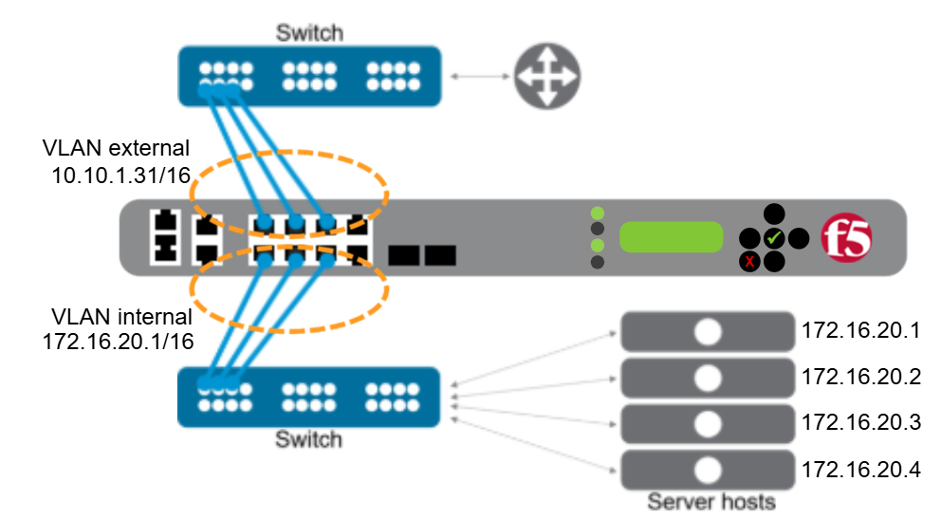

* Self-IP 🡪 address space for hosts in the VLAN
  + Static (non-floating) 🡪 IP address that the BIG-IP system does not share with another BIG-IP system
  + Floating 🡪 BIG-IP systems in a HA device group share
  + Each Self-IP in VLAN are auto assigned a MAC address by BIG-IP system

### NTP

* synchronising clocks of computer systems in a network for accurate time
* Add NTP server onto BIG-IP “Time Server List” using IP address of FQDN

### Device DNS

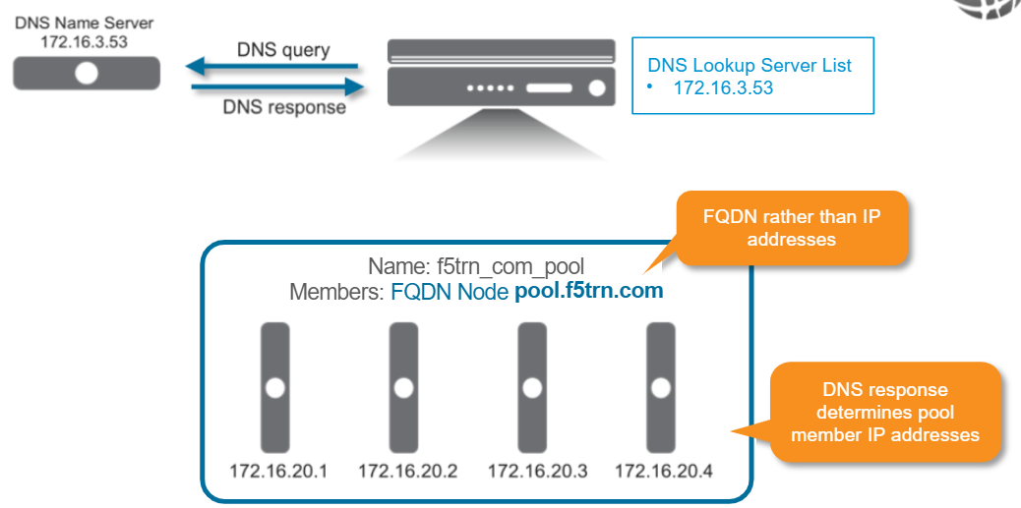

# 3 – Archiving BIG-IP Configuration

* Backup of configuration in the form of user configuration set (UCS) file 🡪 compressed file with important configuration information
  + settings for UCS files can be overridden or customised
* Use of TMSH to create a UCS:  
  `save /sys ucs backup.ucs`  
  Saved in `/var/local/ucs/`
* Restoring a configuration from UCS 🡪 BIG-IP system auto creates a rotating backup of current configuration and saving is as `cs-backup.ucs`.   
  `load /sys ucs restore.ucs`
  + number of files in rotation is set in `cs_backup_rotate.conf`
  + after backup rotation, loaded UCS is placed in stored configuration (disk) and then load the new configuration into memory (running configuration)
  + reboot may be required